# 

# Streaming

# Mavle Mob

# Statistics

April 2017 – February 2020

by Nitish Deshpande

# Mavle Mob Streaming Statistics

**Aim:** This report aims to show insight into the streaming statistics for music published by Mavle Mob. Statistics are shown from April 2017, or from the first publication of the track. Platforms for which statistics are shown are Spotify, YouTube, Apple Music, and SoundCloud. Along with this, there are specific stats shown for ‘Chai Kaffy’, which is an EP / project.

**Note:** All data has been manipulated and organised using MS Excel and T-SQL in SSMS. Visualisations have been created using MS Power BI.

## Table of Contents

Platform Summary 3

Track Summary 4

Spotify Statistics 5

Spotify Streaming Statistics 6

Spotify Listener Statistics 7

Spotify Save Statistics 8

YouTube Views 9

YouTube Views + Followers 10

SoundCloud Plays 11

SoundCloud Plays + Followers 12

Apple Music Streams 13

Instagram + Facebook 14

Chai Kaffy Spotify Statistics 15

Chai Kaffy YouTube Statistics 17

Chai Kaffy SoundCloud Statistics 18

Chai Kaffy Apple Statistics 19

## Platform Summary

## Track Summary

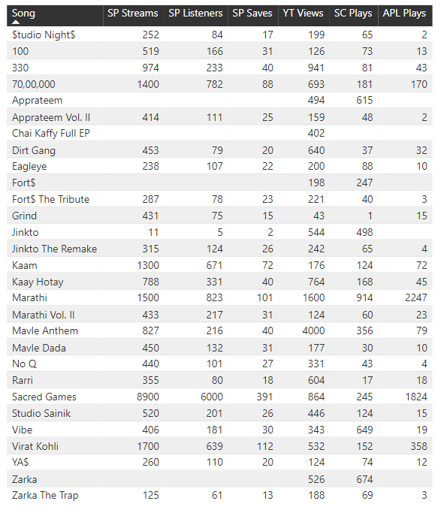

## Spotify Statistics

**Spotify Streams / Listeners / Saves** *All Tracks*

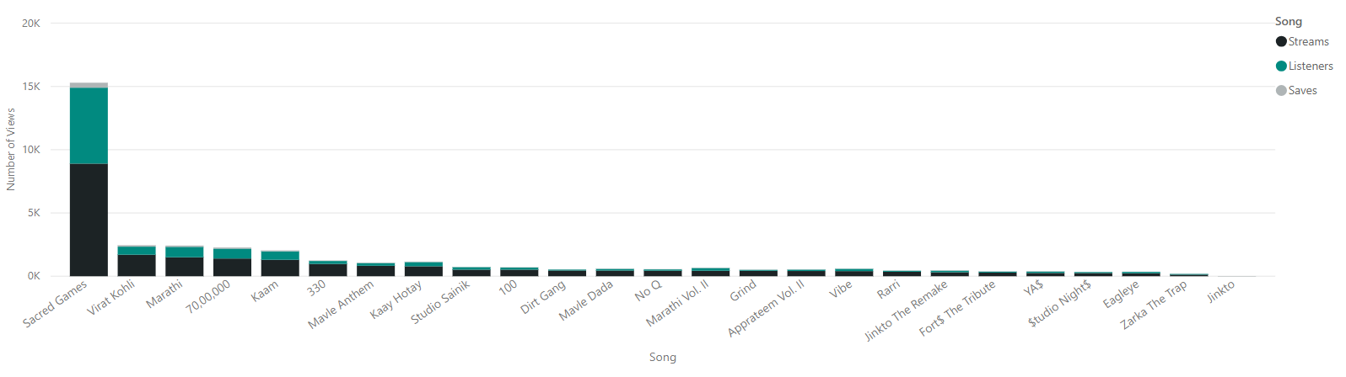

**Spotify Streams / Listeners / Saves** *All Tracks w/out Sacred Games*

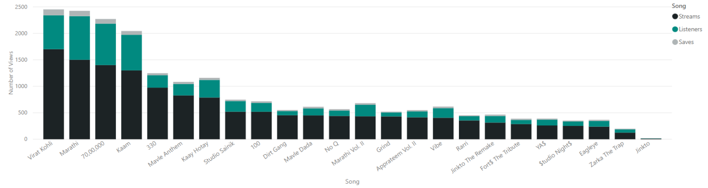

**Spotify Streams / Listeners / Saves** *Total*

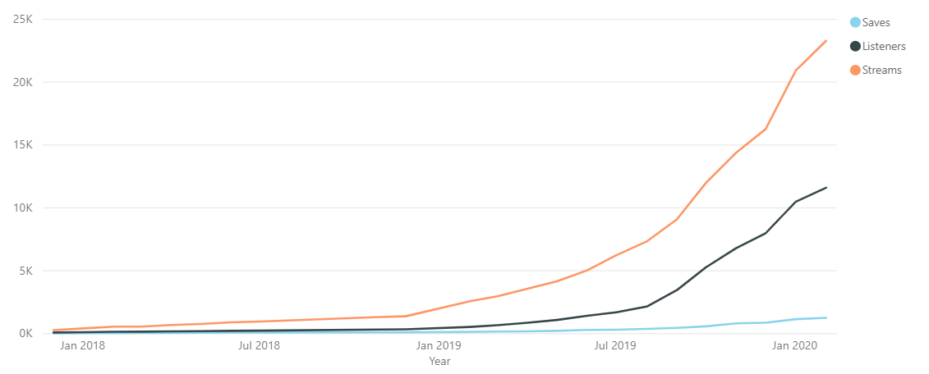

## Spotify Streaming Statistics

**Spotify Streams** *Top Tracks w. Sacred Games*

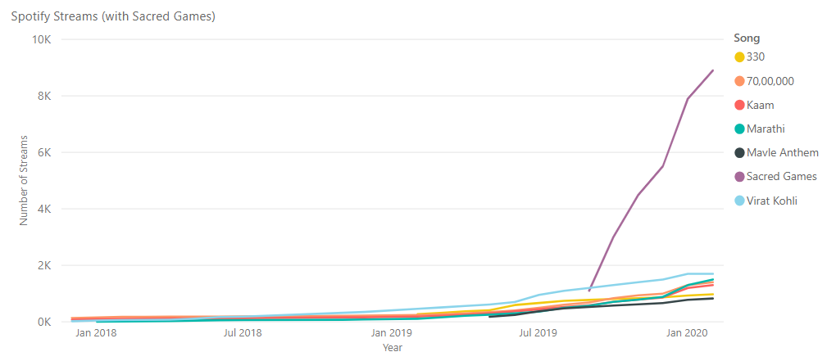

**Spotify Streams** *Top Tracks w/out. Sacred Games*

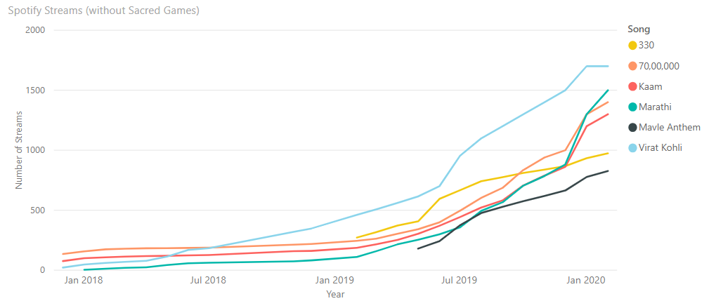

**Spotify Streams** *All Tracks*

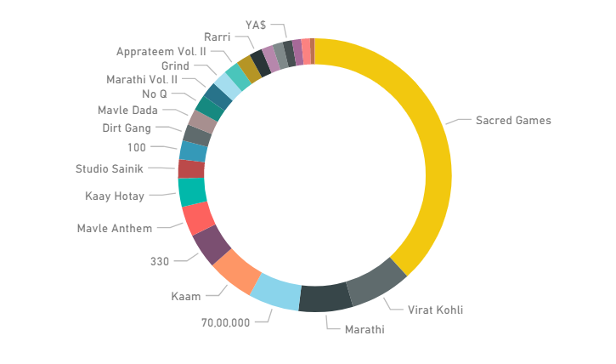

## Spotify Listener Statistics

**Spotify Listeners** *Top Tracks*

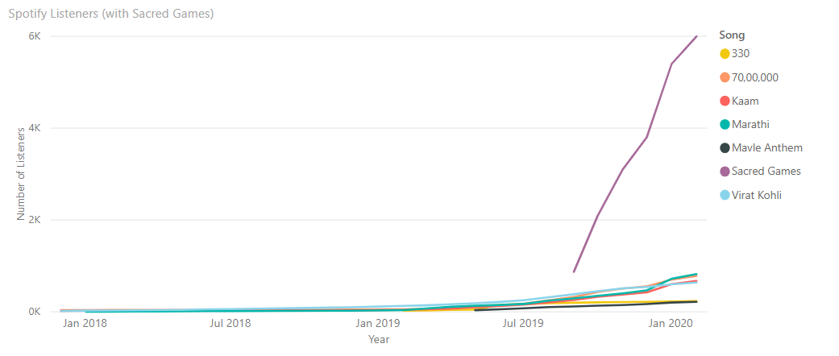

**Spotify Listeners** *Top Tracks w/out Sacred Games*

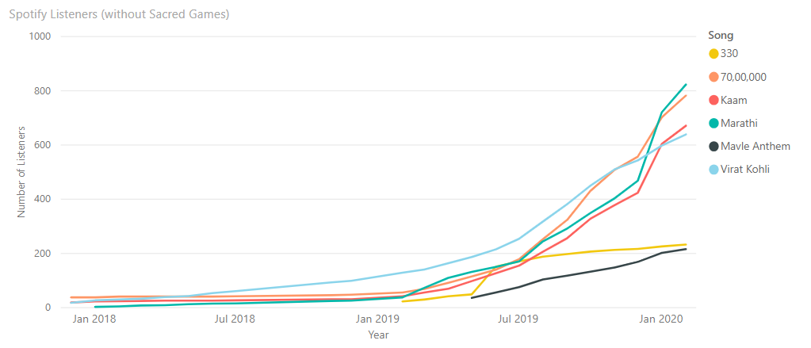

**Spotify Listeners** *All Tracks*

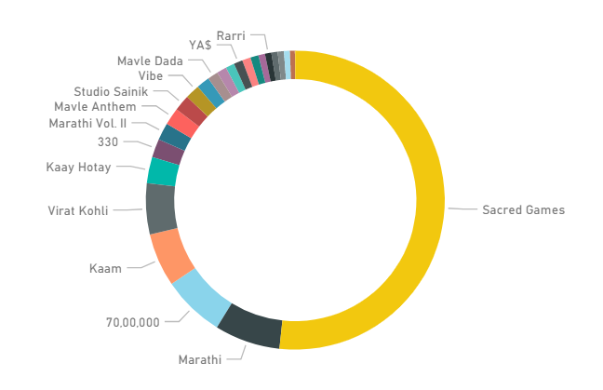

## Spotify Save Statistics

**Spotify Saves** *Top Tracks*

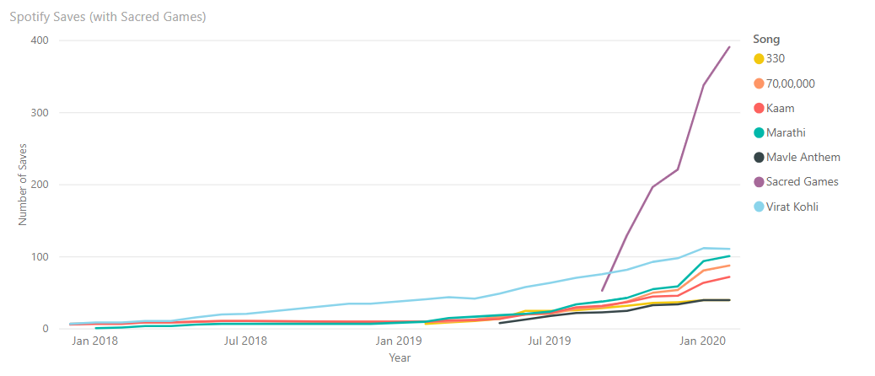

**Spotify Saves** *Top Tracks w/out Sacred Games*

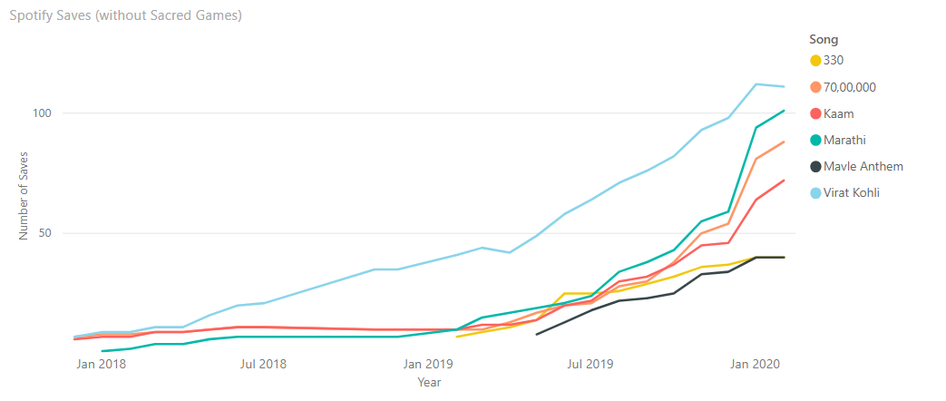

**Spotify Saves** *All Tracks*

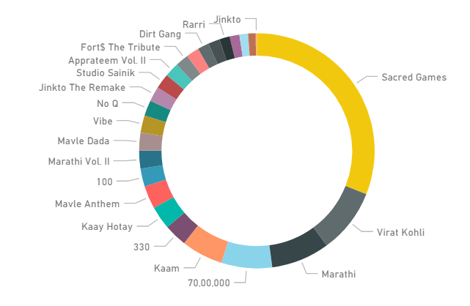

## YouTube Views

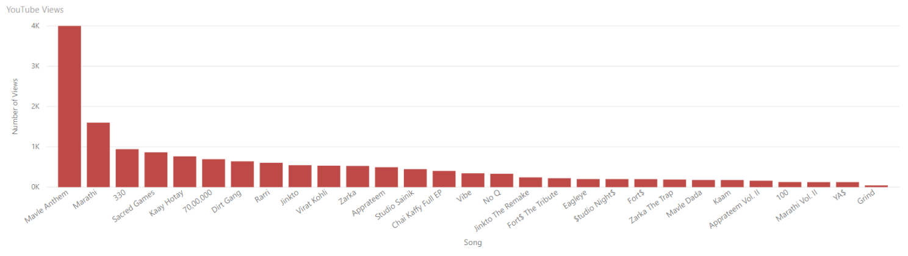**YouTube Views** *All Tracks*

**YouTube Views** *Tracks under 1000 views*

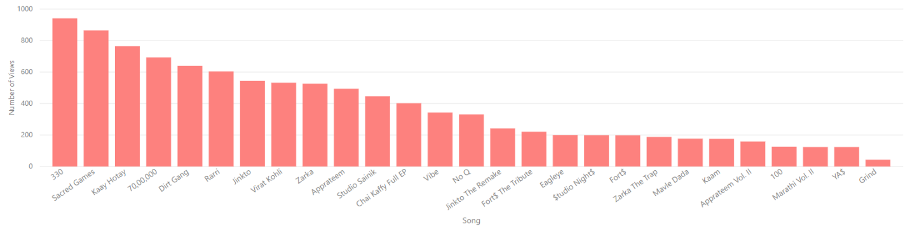

**YouTube Views** *Top Tracks*

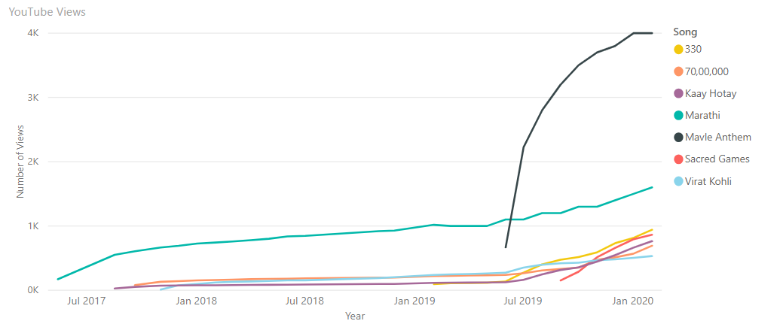

## YouTube Views + Followers

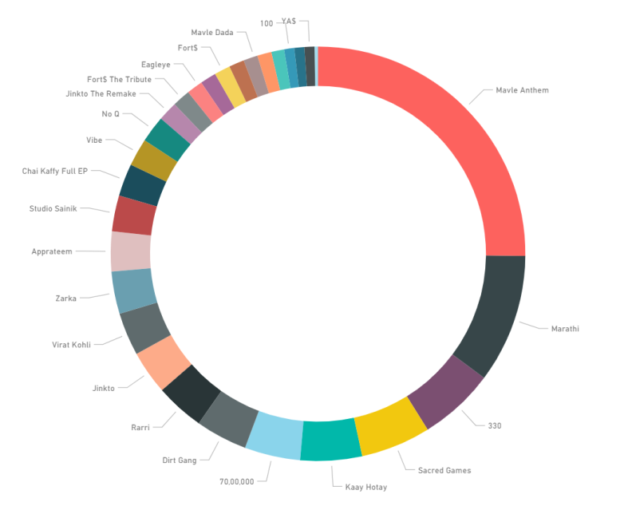**YouTube Views** *All Tracks*

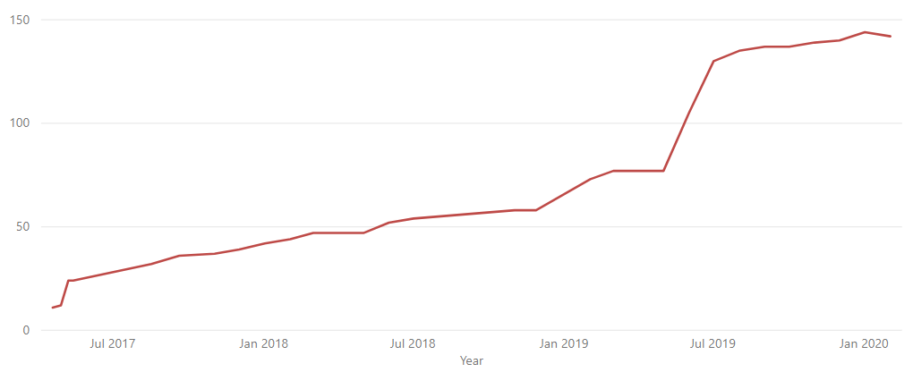**YouTube Followers**

## SoundCloud Plays

**SoundCloud Plays** *All Tracks*

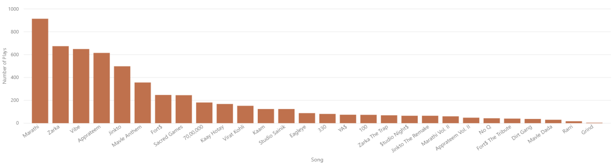

**SoundCloud Plays** *All Tracks w/out Top Tracks*

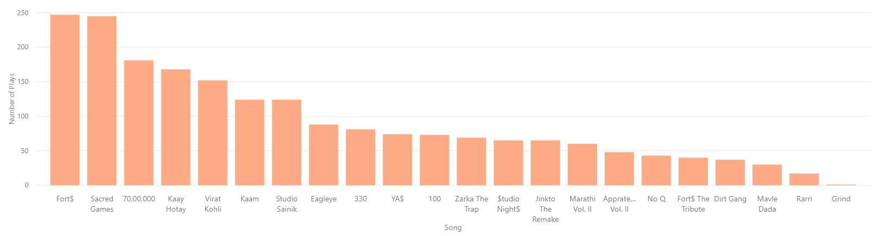

**SoundCloud Plays** *Top Tracks*

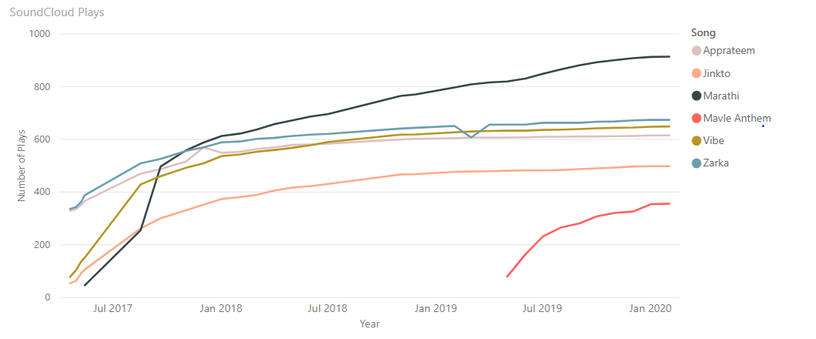

## SoundCloud Plays + Followers

**SoundCloud Plays** *All Tracks*

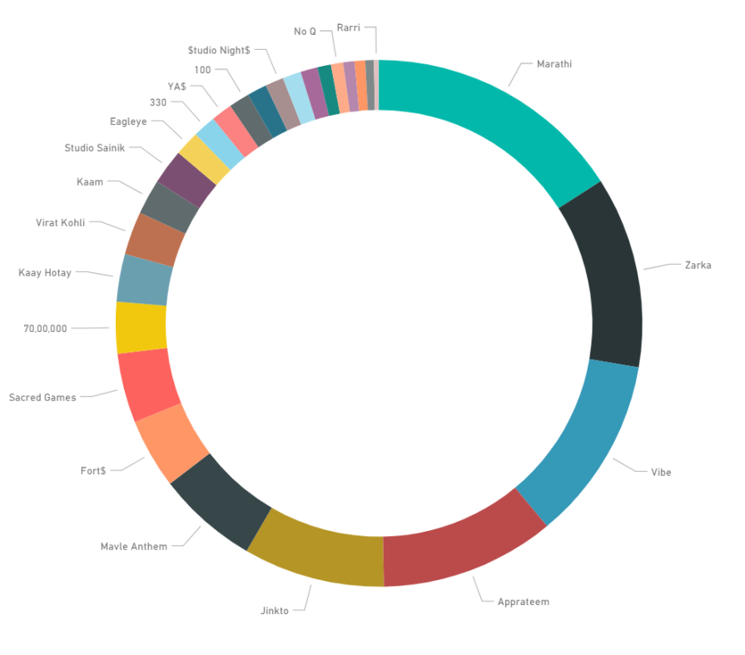

**SoundCloud Followers**

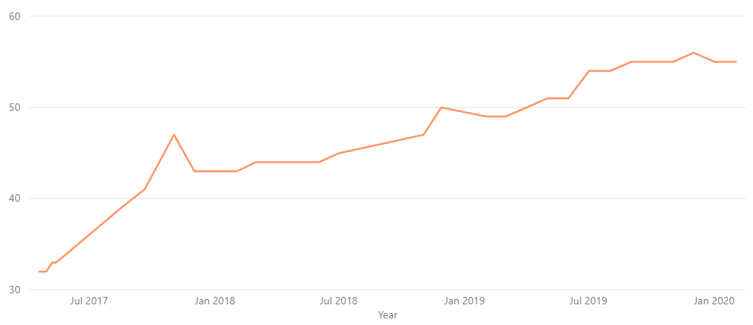

## Apple Music Streams

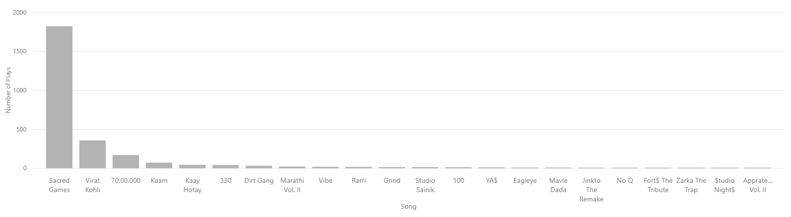**Apple Music Streams** *All Tracks*

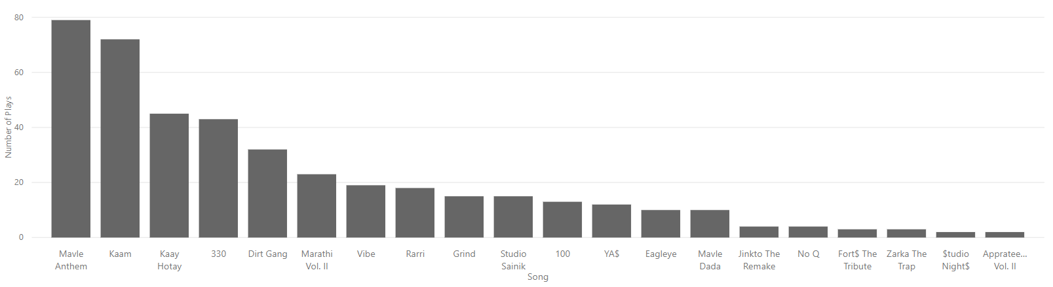**Apple Music Streams** *All Tracks w/out Top Tracks*

**Apple Music Streams** *Top Tracks*

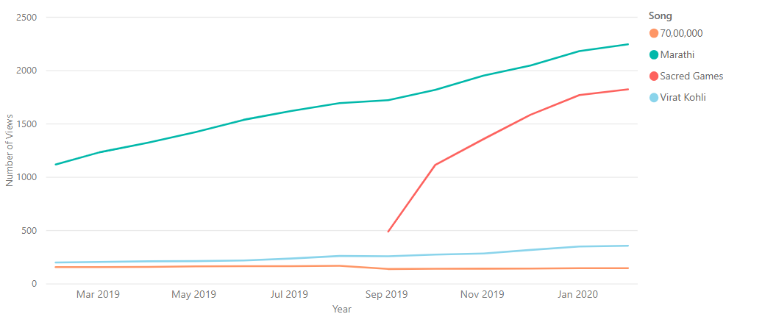

**Apple Music Streams** *All Tracks*

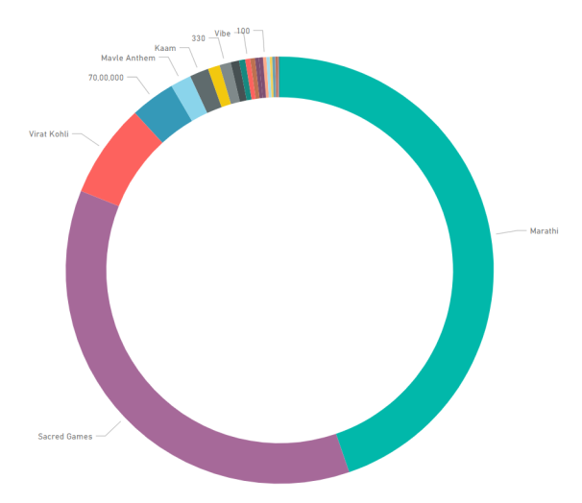

## Instagram + Facebook

**Instagram Followers**

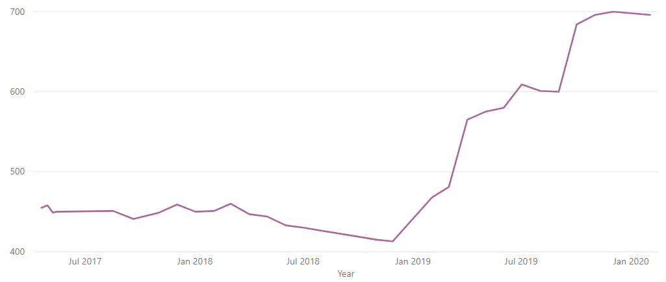

**Facebook Followers**

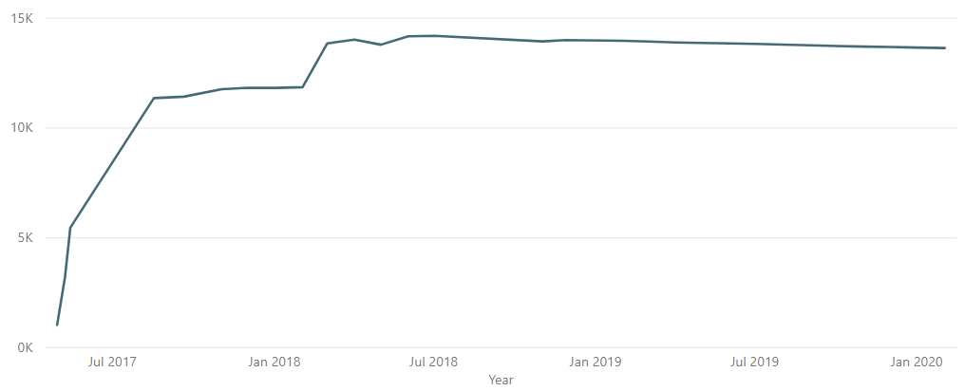

## Chai Kaffy Spotify Statistics

**Spotify Statistics**

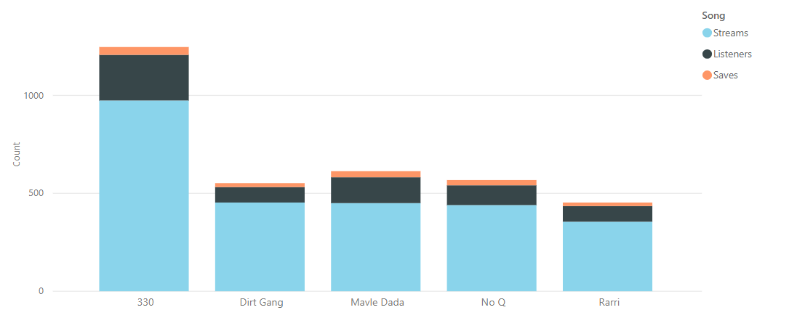

**Spotify Streams**

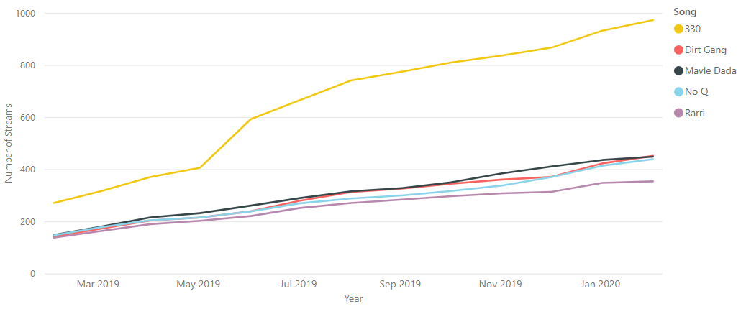

**Spotify Listeners**

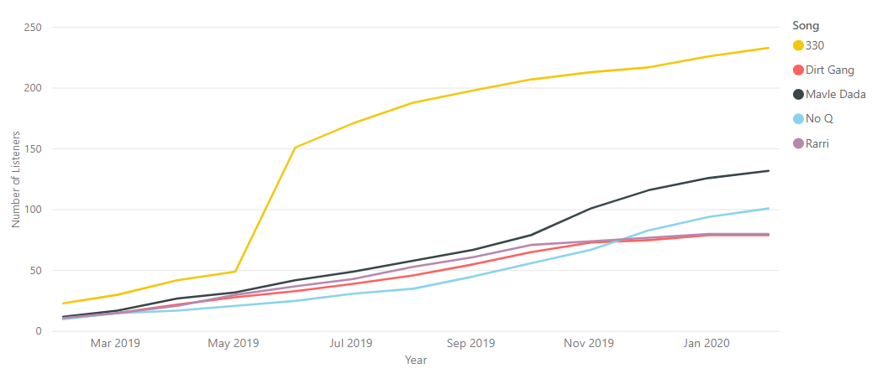

**Spotify Saves**

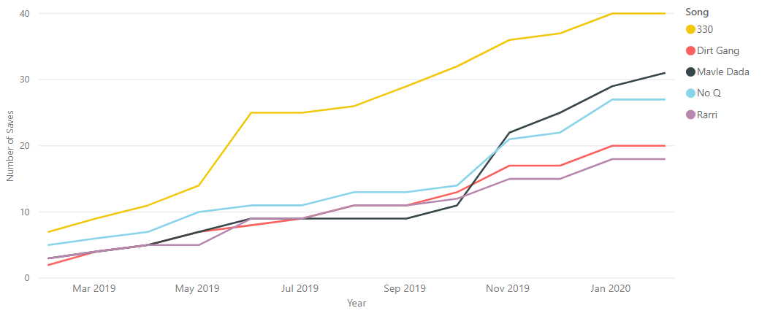

## Chai Kaffy YouTube Statistics

**YouTube Views**

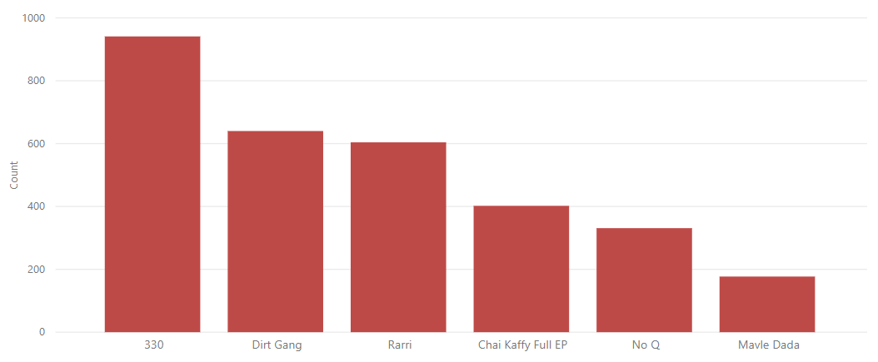

**YouTube Views**

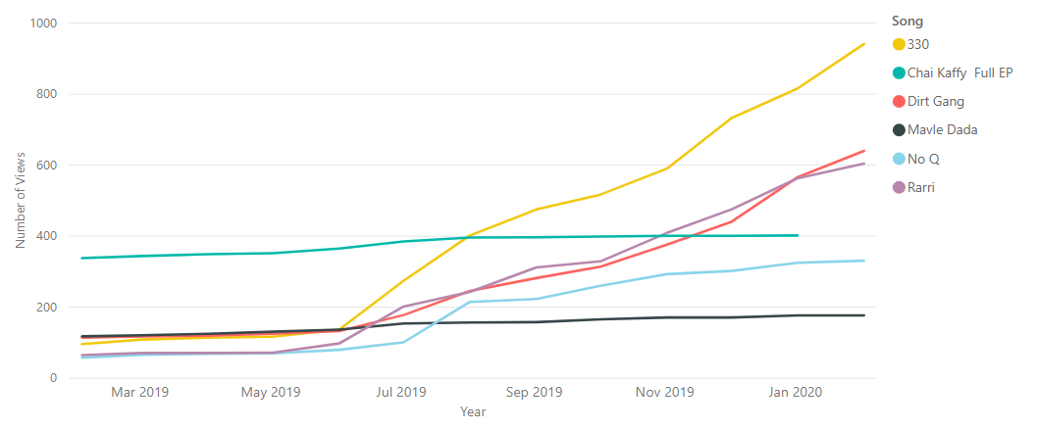

## Chai Kaffy SoundCloud Statistics

**SoundCloud Plays**

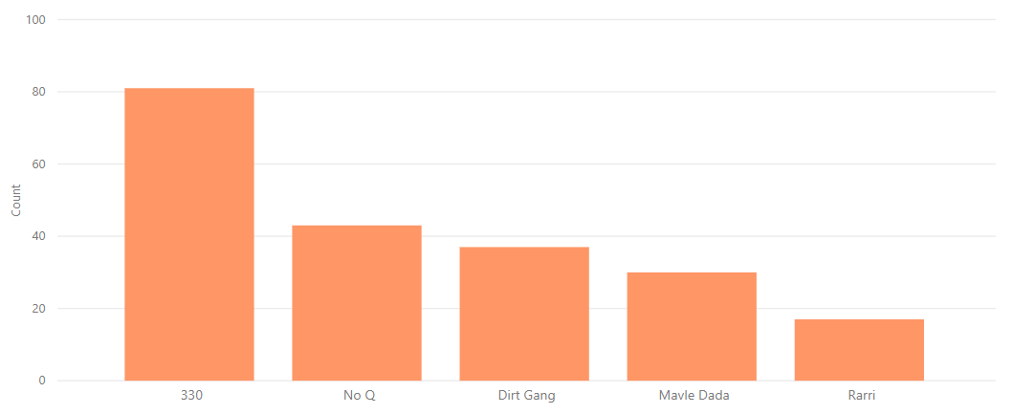

**SoundCloud Plays**

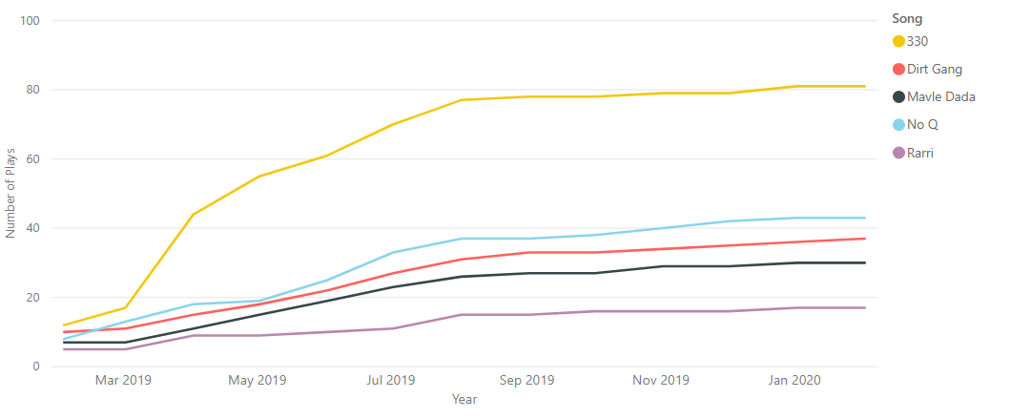

## Chai Kaffy Apple Statistics

**Apple Plays**

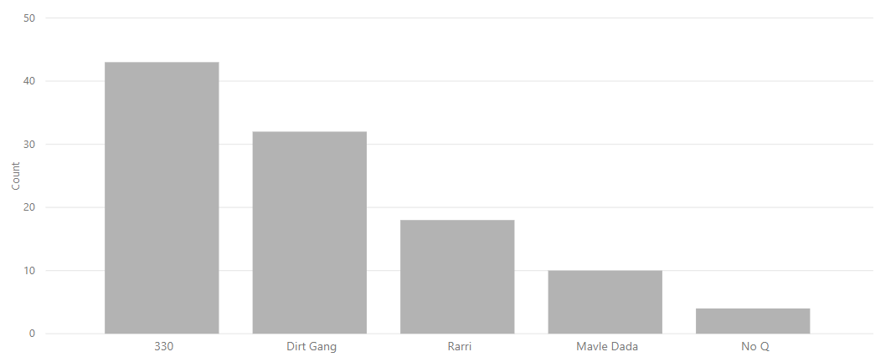

**Apple Plays**

